PLANT SOURCED RANDOM CARRIER WAVE GENERATION FOR MOTOR DRİVE WITH LOWER THDs

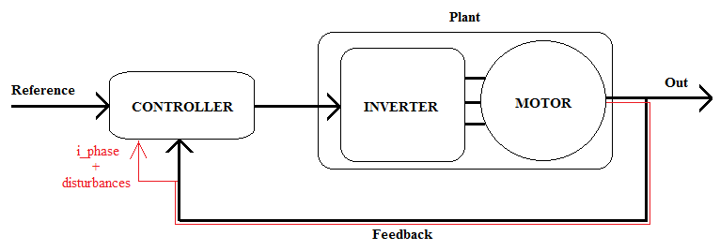

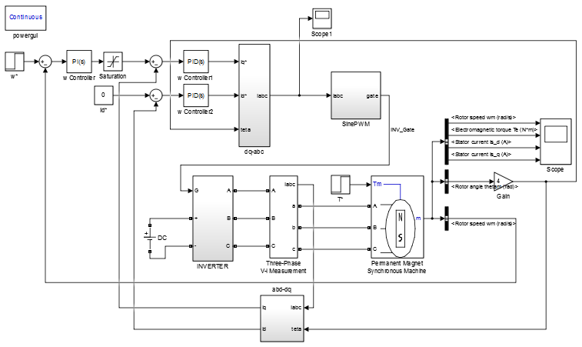

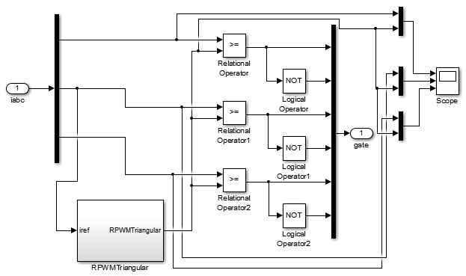

Extension of SinePWM Block

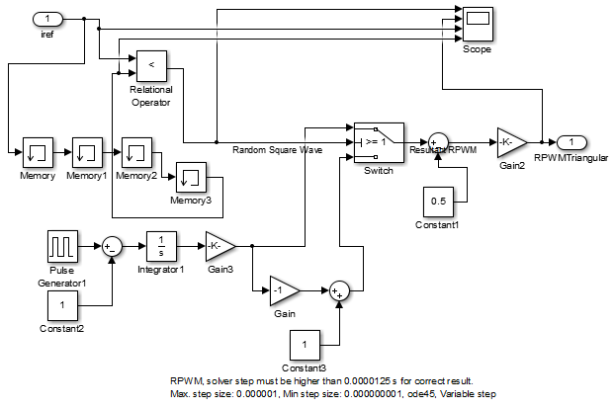

Extension of Motor phase current sourced RPWM carrier